Program(MainActivity):

package com.example.exp3;

import android.os.Bundle;

import android.app.Activity;

import android.view.Menu;

import android.view.View;

import android.widget.Button;

import android.widget.EditText;

public class MainActivity extends Activity {

Button b1,b2,b3,b4,b5,b6,b7,b8,b9,b10,b11,b12,b13,b14,b15,b16;

EditText e1;

int a,b,r;

char op;

@Override

protected void onCreate(Bundle savedInstanceState) {

super.onCreate(savedInstanceState);

setContentView(R.layout.activity_main);

b1 = (Button) findViewById(R.id.button1);

e1 = (EditText) findViewById(R.id.editText1); }

public void zero(View View){

e1.append("0"); }

public void one(View view){

e1.append("1"); }

public void two(View view){

e1.append("2"); }

public void three(View view){

e1.append("3"); }

public void four(View view){

e1.append("4"); }

public void five(View view){

e1.append("5"); }

public void six(View view){

e1.append("6"); }

public void seven(View view){

e1.append("7"); }

public void eight(View view){

e1.append("8"); }

public void nine(View view){

e1.append("9"); }

public void addition(View view) {

a= Integer.parseInt(e1.getText().toString());

e1.setText("");

op = '+'; }

public void subtraction(View view){

a = Integer.parseInt(e1.getText().toString());

e1.setText("");

op ='-'; }

public void multiplication(View view){

a = Integer.parseInt(e1.getText().toString());

e1.setText("");

op ='*'; }

public void division(View view){

a = Integer.parseInt(e1.getText().toString());

e1.setText("");

op = '/'; }

public void cancel(View View){

e1.setText(""); }

public void equal(View view){

b = Integer.parseInt(e1.getText().toString());

e1.setText("");

switch(op){

case'+':

r = a + b;

e1.setText(Integer.toString(r));

break;

case'-':

r = a-b;

e1.setText(Integer.toString(r));

break;

case'*':

r = a*b;

e1.setText(Integer.toString(r));

break;

case'/':

r = a/b;

e1.setText(Integer.toString(r));

break; } }

@Override

public boolean onCreateOptionsMenu(Menu menu) {

getMenuInflater().inflate(R.menu.main, menu);

return true; } }

Program(activity_main):

<LinearLayout xmlns:android="http://schemas.android.com/apk/res/android"

android:layout_width="fill_parent"

android:layout_height="fill_parent"

android:orientation="vertical" >

<LinearLayout

android:layout_width="match_parent"

android:layout_height="wrap_content"

android:orientation="horizontal" >

<TextView

android:id="@+id/textView1"

android:layout_width="wrap_content"

android:layout_height="wrap_content"

android:text="Calculator"

android:layout_marginLeft="105dp"

android:textAppearance="?android:attr/textAppearanceLarge" />

</LinearLayout>

<LinearLayout

android:layout_width="match_parent"

android:layout_height="wrap_content" >

<EditText

android:id="@+id/editText1"

android:layout_width="0dp"

android:layout_height="wrap_content"

android:layout_weight="1"

android:ems="10"

android:inputType="number" >

<requestFocus />

</EditText>

</LinearLayout>

<LinearLayout

android:layout_width="fill_parent"

android:layout_height="wrap_content"

android:orientation="horizontal"

android:layout_marginLeft="65dp">

<Button

android:id="@+id/button1"

style="?android:attr/buttonStyleSmall"

android:layout_width="wrap_content"

android:layout_height="wrap_content"

android:onClick="zero"

android:text="0" />

<Button

android:id="@+id/button2"

style="?android:attr/buttonStyleSmall"

android:layout_width="wrap_content"

android:layout_height="wrap_content"

android:onClick="one"

android:text="1" />

<Button

android:id="@+id/button3"

style="?android:attr/buttonStyleSmall"

android:layout_width="wrap_content"

android:layout_height="wrap_content"

android:onClick="two"

android:text="2" />

<Button

android:id="@+id/button4"

style="?android:attr/buttonStyleSmall"

android:layout_width="wrap_content"

android:layout_height="wrap_content"

android:onClick="three"

android:text="3" />

</LinearLayout>

<LinearLayout

android:layout_width="match_parent"

android:layout_height="wrap_content"

android:orientation="horizontal"

android:layout_marginLeft="65dp" >

<Button

android:id="@+id/button5"

style="?android:attr/buttonStyleSmall"

android:layout_width="wrap_content"

android:layout_height="wrap_content"

android:onClick="four"

android:text="4" />

<Button

android:id="@+id/button6"

style="?android:attr/buttonStyleSmall"

android:layout_width="wrap_content"

android:layout_height="wrap_content"

android:onClick="five"

android:text="5" />

<Button

android:id="@+id/button7"

style="?android:attr/buttonStyleSmall"

android:layout_width="wrap_content"

android:layout_height="wrap_content"

android:onClick="six"

android:text="6" />

<Button

android:id="@+id/button8"

style="?android:attr/buttonStyleSmall"

android:layout_width="wrap_content"

android:layout_height="wrap_content"

android:onClick="seven"

android:text="7" />

</LinearLayout>

<LinearLayout

android:layout_width="match_parent"

android:layout_height="wrap_content"

android:orientation="horizontal"

android:layout_marginLeft="65dp" >

<Button

android:id="@+id/button9"

style="?android:attr/buttonStyleSmall"

android:layout_width="wrap_content"

android:layout_height="wrap_content"

android:onClick="eight"

android:text="8" />

<Button

android:id="@+id/button10"

style="?android:attr/buttonStyleSmall"

android:layout_width="wrap_content"

android:layout_height="wrap_content"

android:onClick="nine"

android:text="9" />

<Button

android:id="@+id/button11"

style="?android:attr/buttonStyleSmall"

android:layout_width="wrap_content"

android:layout_height="wrap_content"

android:onClick="addition"

android:text="+" />

<Button

android:id="@+id/button12"

style="?android:attr/buttonStyleSmall"

android:layout_width="wrap_content"

android:layout_height="wrap_content"

android:onClick="subtraction"

android:text="-" />

</LinearLayout>

<LinearLayout

android:layout_width="match_parent"

android:layout_height="wrap_content"

android:orientation="horizontal"

android:layout_marginLeft="65dp" >

<Button

android:id="@+id/button13"

style="?android:attr/buttonStyleSmall"

android:layout_width="wrap_content"

android:layout_height="wrap_content"

android:onClick="multiplication"

android:text="*" />

<Button

android:id="@+id/button14"

style="?android:attr/buttonStyleSmall"

android:layout_width="wrap_content"

android:layout_height="wrap_content"

android:onClick="division"

android:text="/" />

<Button

android:id="@+id/button15"

style="?android:attr/buttonStyleSmall"

android:layout_width="wrap_content"

android:layout_height="wrap_content"

android:onClick="equal"

android:text="=" />

<Button

android:id="@+id/button16"

style="?android:attr/buttonStyleSmall"

android:layout_width="wrap_content"

android:layout_height="wrap_content"

android:onClick="cancel"

android:text="C" />

</LinearLayout>

</LinearLayout>

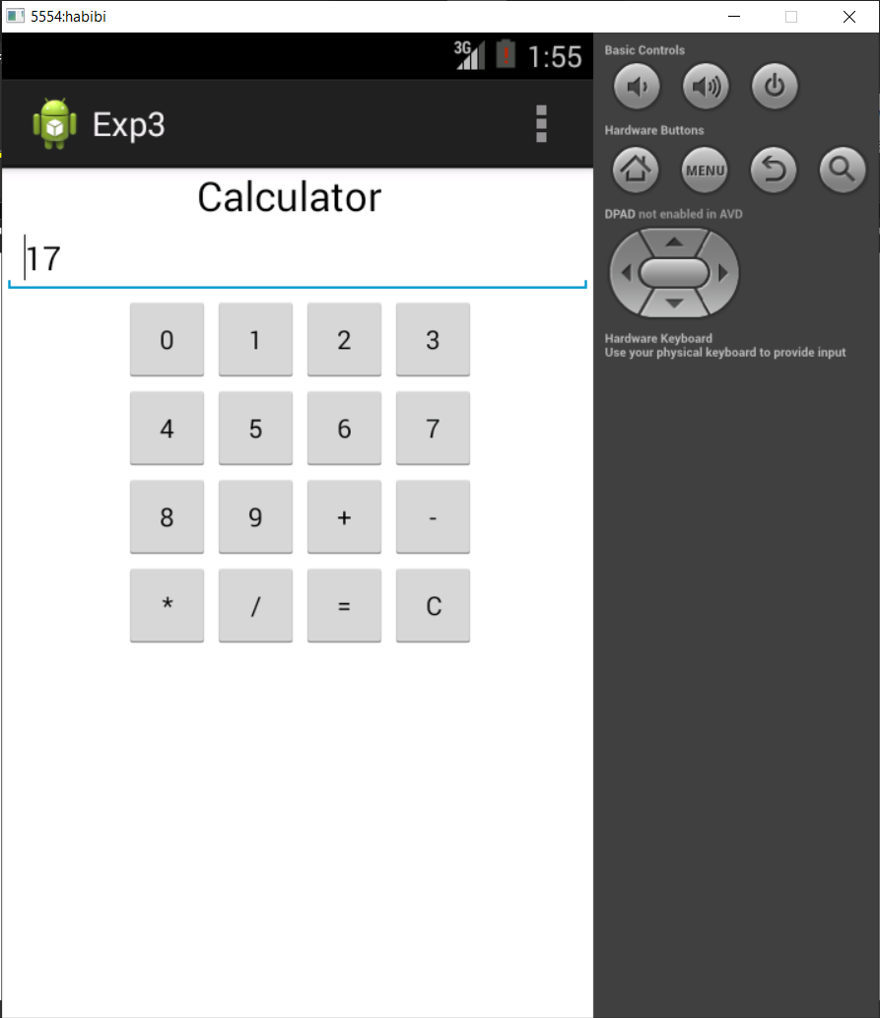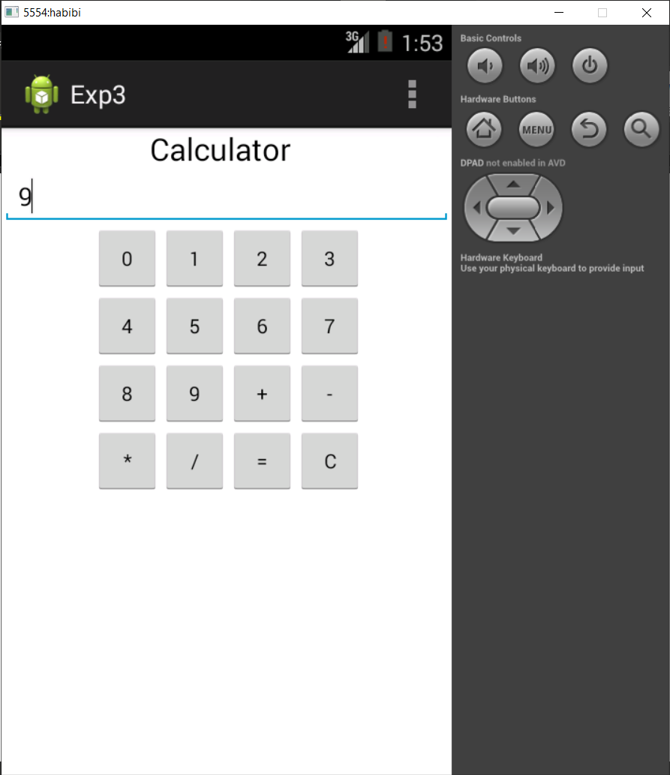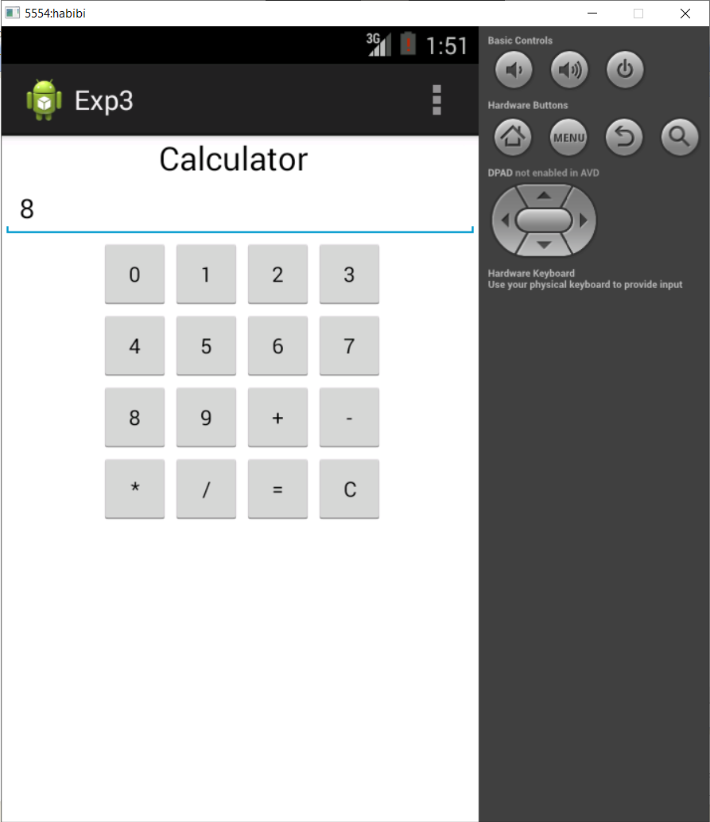OUTPUT(Addition):

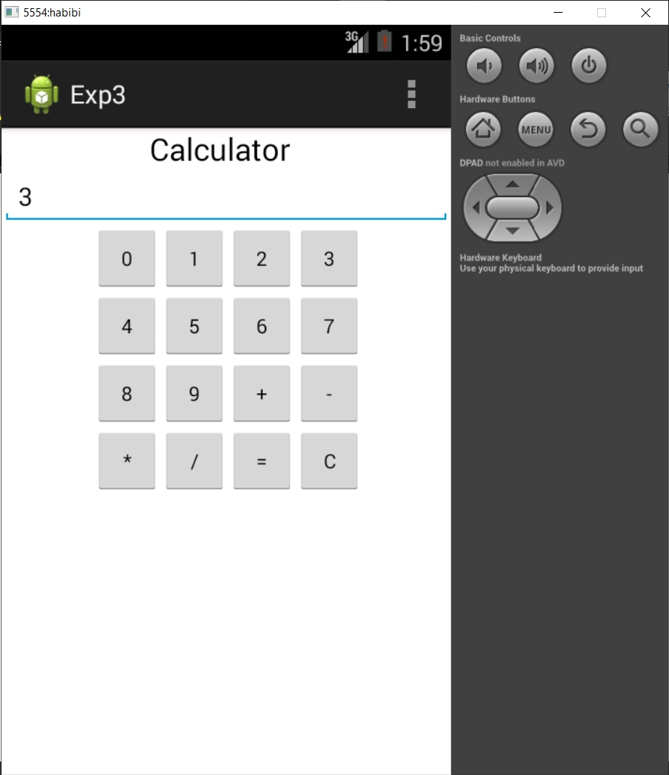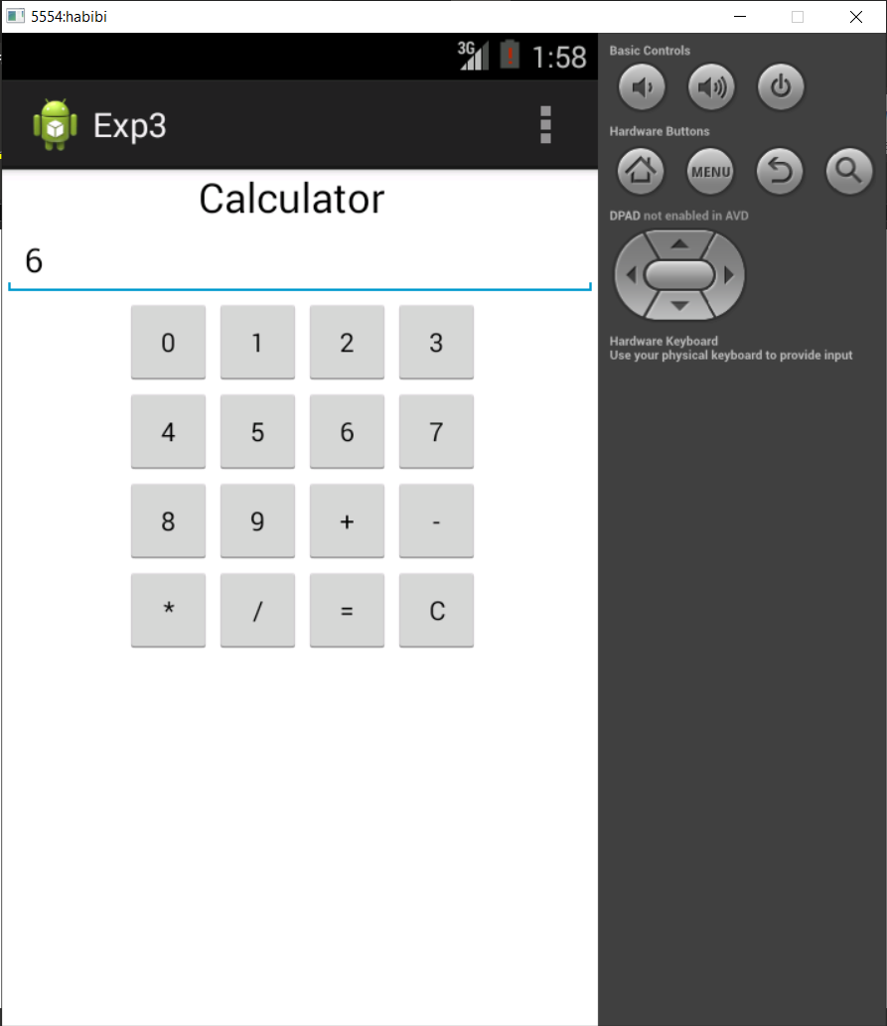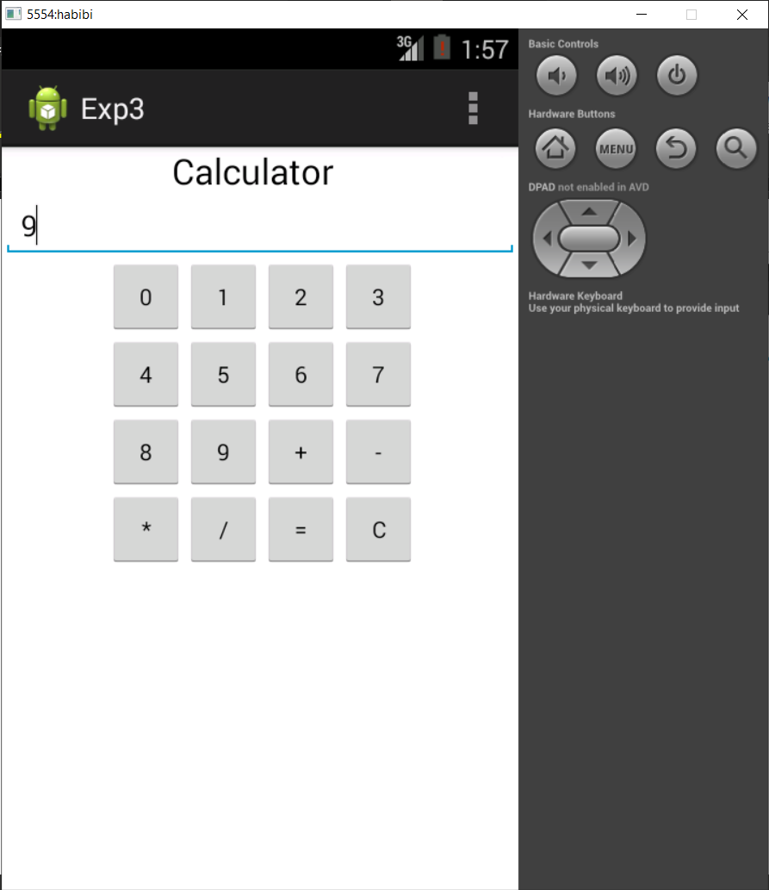(Subtraction):

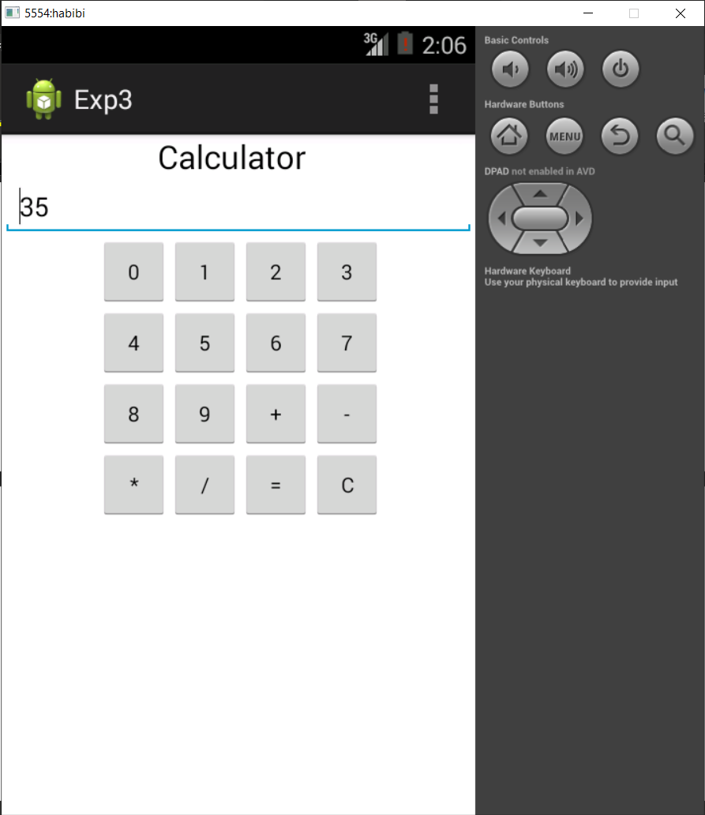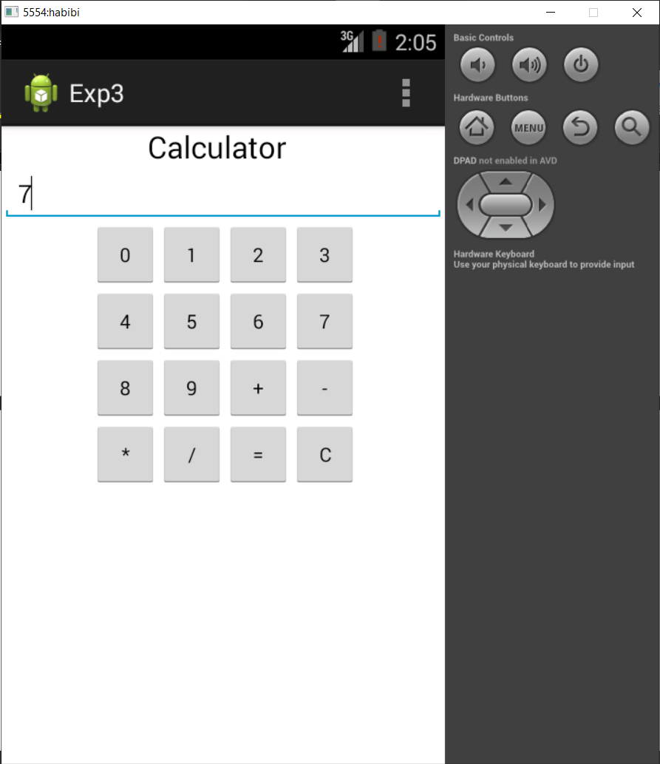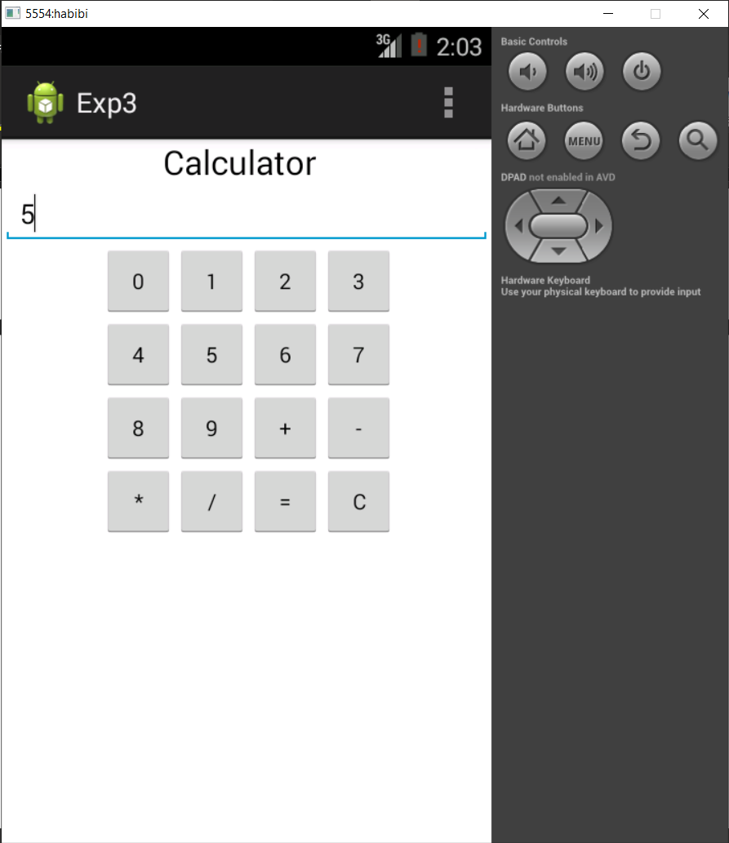(Multiplication):

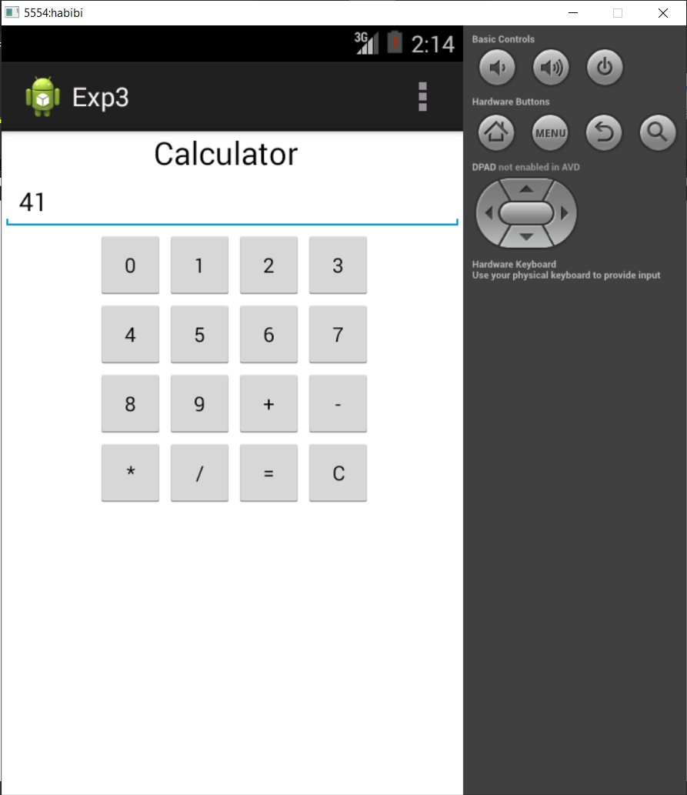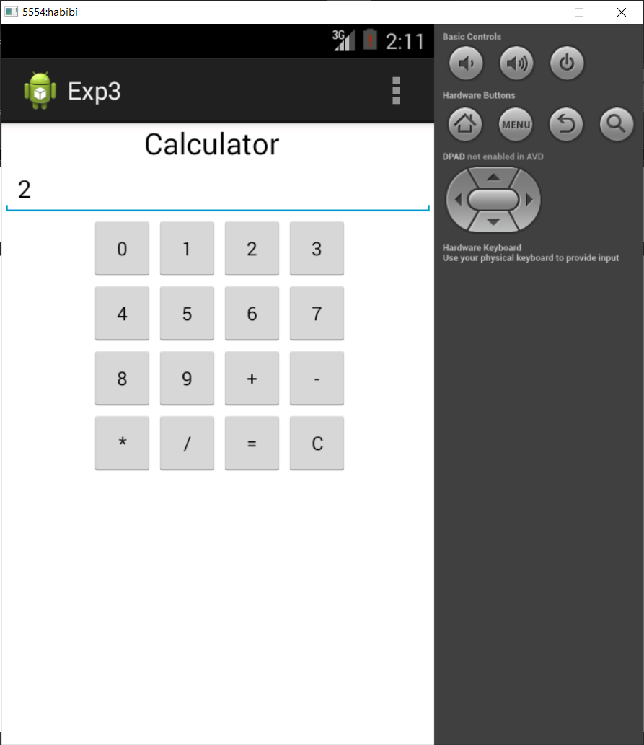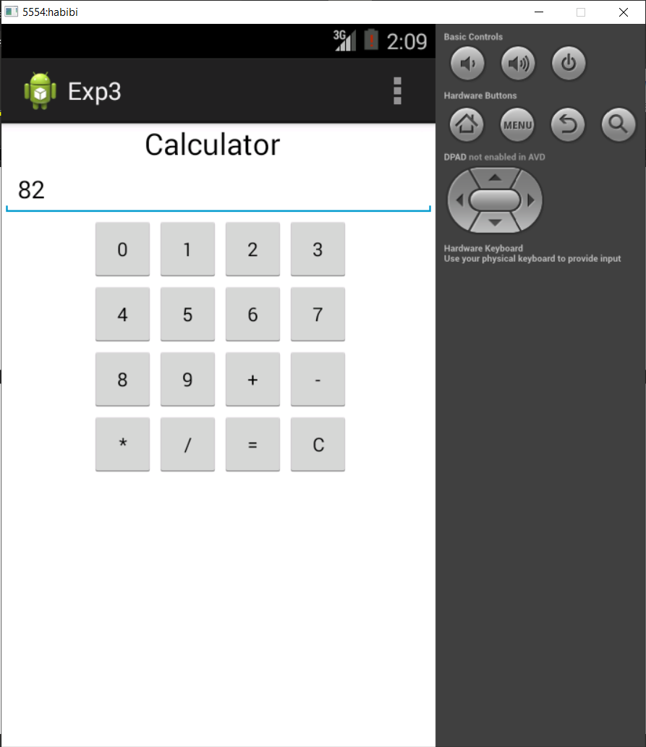(Division):